**Assignment #3:**

**Student Name: The Cuong, Bui**

**Student ID: C0770339**

**Date: Nov 4, 2019**

1. Write SQL code that will create the table structure for a table named EMP_1. Remember that the JOB_CODE is the foreign key to JOB table.

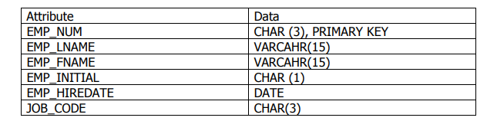

Create Database EMPLOYEE;

create table JOB(

Job_code Char(3) not null primary key,

Job_description varchar(25));

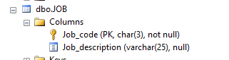

Create table EMP_1(

EMP_NUM CHAR(3) not null,

EMP_LNAME VARCHAR(15),

EMP_FNAME VARCHAR(15) not null,

EMP_INITIAL char(1),

EMP_HIREDATE Date not null,

JOB_CODE char(3) not null,

primary key(EMP_NUM),

foreign key (Job_CODE)

references JOB(Job_code));

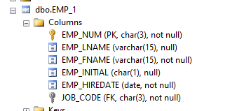

1. Write a SQL codes to populate the EMP_1 as below:

insert into JOB VALUES ('200', 'HUMAN RESOURCE');

insert into JOB VALUES ('500', 'IT ENGINEERING');

insert into JOB VALUES ('501', 'SOFT DEVELOPER ENGINEERING');

insert into JOB VALUES ('502', 'SOFT TESTER ENGINEERING');

insert into JOB VALUES ('503', 'PROJECT MANAGER');

insert into JOB VALUES ('504', 'PROJECT MANAGER');

insert into JOB VALUES ('505', 'DIRECTOR');

insert into JOB VALUES ('506', 'ADMIN');

SELEct * from JOB;

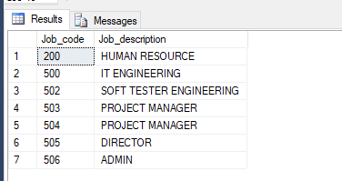

insert into EMP_1 VALUES (101, 'NEWS', 'JOHN', 'G', '02-01-2011', '502');

insert into EMP_1 VALUES (102, 'SENIOR', 'DAVID', 'H', '01-09-2014', '500');

insert into EMP_1 VALUES (103, 'JOHNSON', 'ALICE', 'J', '07-06-2013', '500');

insert into EMP_1 VALUES (104, 'ALONZO', 'MARIA', 'L', '09-02-2016', '200');

insert into EMP_1 VALUES (105, 'RADILFO', 'RALK', 'Y', '05-05-2015', '506');

select * from EMP_1;

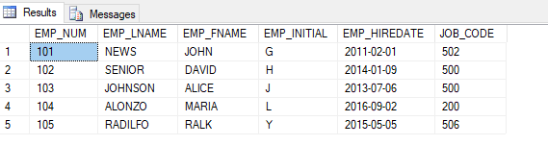

3. Write the SQL code that changes the job code 500 for the employee number 103.

-- Alter EMP_1 DB

alter table EMP_1 nocheck constraint FK__EMP_1__JOB_CODE__1273C1CD

update EMP_1 SET EMP_1.JOB_CODE = '501' where EMP_NUM= '103';

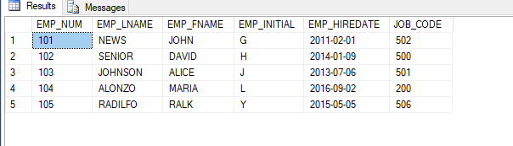

4. Write a SQL code to delete a row with person with the name Ralk Radolfo with hire date 05-05-2015.

delete from EMP_1 where (EMP_FNAME = 'RALK' and EMP_LNAME = 'RADILFO' and EMP_HIREDATE = '05-05-2015');

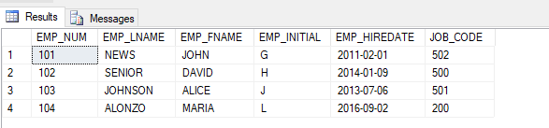

5. Write a SQL code that will find the count of the employees hired after 01-02-2011.

select count(*) as 'count of the employees hired after 01-02-2011' from EMP_1 where EMP_HIREDATE > '01-02-2011';

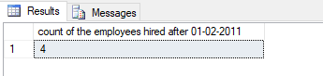

6. Write a SQL code that print the name of all the employees ordered by last name first and then their employee number having job codes > 200.

select EMP_LNAME, EMP_FNAME from EMP_1 where JOB_CODE > 200 order by EMP_FNAME;

7. Write a SQL code that updates employee EMP_FNAME to Sara with EMP_NUM 101.

update EMP_1 SET EMP_FNAME = 'Sara' where EMP_NUM= '101';

